JavaScript complex Assignment

# Array Functions Assignment

16. Create a function named reversePlusOne. This function should:

* + Take one argument, an array of at least two numbers.
  + This function should return:
    - the array *reversed* with a 1 added at the front

For example:

reversePlusOne([1,2]); // returns [1,2,1]

reversePlusOne([5,4,3,2]); // returns [1,2,3,4,5]

**ans:-**

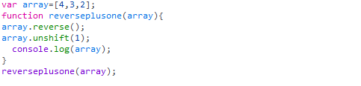

* Create a function named plusesEverywhere. This function should:
  + Take one argument, an array of at least two numbers.
  + This function should return:
    - a String made of all the values in the array separated by +

For example:

plusesEverywhere([1,2,3]); // returns "1+2+3"

plusesEverywhere([18,24]); // returns "18+24

**Ans**

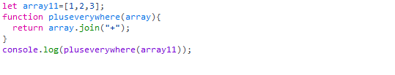

* Create a function named arrayQuantityPlusOne. This function should:
  + Take one argument, an array of numbers.
  + This function should return:
    - one greater than the number of items in the array

For example:

arrayQuantityPlusOne([0,0,1,0,2,1]); // returns 7

arrayQuantityPlusOne([42]); // returns 2

**Ans**

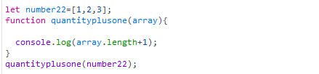

# Object Oriented Basics

17. Complete the createCourse function. This function should:

* + take three arguments that will define course properties
    - courseTitle (string)
    - courseDuration (string)
    - courseStudents (array)
  + return an object that has each property assigned its proper value

For example:

createCourse('Bloc Front-End Engineering', '4 weeks', ['Joe', 'Tim', 'Rob'])

// should return {title: 'Bloc Front-End Engineering', duration: '4 weeks', students: ['Joe', 'Tim', 'Rob']}

**Ans**

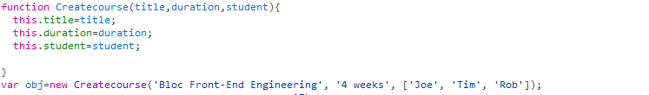

* Complete the addProperty function. This function should:
  + Take three arguments:
    - object: an object to add a properties to
    - newProp: a property that we want to add to the object
    - newValue: a value that we want the new property to have
  + If object doesn't already have a property named newProp, then add newProp with value of newValue to object
  + If object already has newProp, return the object argument.

For example:

addProperty({}, 'firstName', 'Jim') // should return { firstName: 'Jim' }

addProperty({firstName: 'Rob'}, 'firstName', 'Jim') // should return {firstName: 'Rob'}

**Ans**

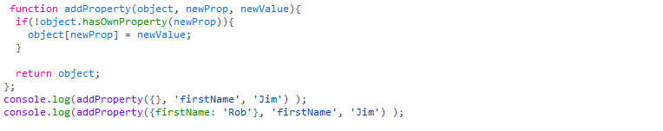

* Complete the formLetter function. This function should:
  + take one argument, a letter, which has three properties recipient, sender, and msg
  + combine the three properties into a single string with an additional greeting and closing
  + insert additional new lines between the greeting, message, and signature.

For example:

formLetter({ recipient: "James", sender: "Richard", msg: "Things are well." })

// should return "Hello James,\n\nThings are well.\n\nSincerely,\nRichard"

**Ans**

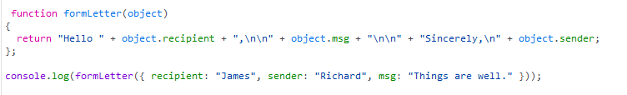

* Complete the canIGet function. This function should:
  + Take two arguments:
    - item: represents what the user wants to buy
    - money: represents how many dollars a user has
  + return true if a user can afford a given item according to the price chart below, and false otherwise:
    - 'MacBook Air' - $999
    - MacBook Pro' - $1299
    - 'Mac Pro' - $2499
    - 'Apple Sticker' - $1
  + Return false if the item is not in the above list of Apple products

Do this with 0 'if' conditions! (Hint: Place the above price table in an object).

For example:

canIGet('MacBook Air', 100) // returns false

canIGet('MacBook Air', 1000) // returns true

**Ans**

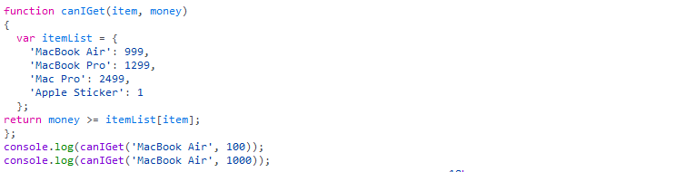

# Strings Assignment

We'll be working on five functions for this exercise.

18. Complete the formLetter function. This function should:

* + Take three strings as arguments: the first name of the recipient, the sender's signature name, and the message of the letter
  + combine the three into a single string with additional greetings and closings
  + insert additional new lines between the greeting, message, and signature

For example:

Ex.formLetter("James", "Richard", "Things are well.");

...should return:

"Hello James,\n\nThings are well.\n\nSincerely,\nRichard"

**Ans**



* Complete the sliceItAndCombineIt function. This function should:
  + take a string and four indices (numbers)
  + return a new string which is the concatenation of two substrings marked by the first and second index of each pair of indices. For example:

sliceItAndCombineIt("This is a Test", 0, 4, 5, 7) // returns "Thisis"

sliceItAndCombineIt("This is a Test", 0, 4, 1, 2) // returns "Thish".

**Ans**

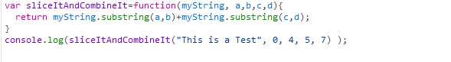

* Complete the findFirstMatch function. This function should:
  + Take two strings as arguments. The first string is the one to search, the second is the one to search for.
  + Return the position (i.e. index) of the first match of string being searching for

For example:

findFirst("Roses are red", "re") // returns 7 (the position of the "re" in "are")

**Ans**



* Complete the findLastMatch function. This function should:
  + Take two strings as arguments. The first string is the one to search, the second is the one to search for
  + Return the position (a.k.a. the index) of the last match of string we're searching for For example:

findFirst("Roses are red", "re") returns 10 (the position of the "re" in "red")

**Ans**

**C:\Users\akswamy\Desktop\es6\18d.PNG**

* Complete the substringBetweenMatches function. This function should:
  + Take two strings as arguments. The first string is the one to search, the second is the one to search for
  + Return the substring between the first match and the last match
  + Not include the first match or the last match in the returned substring For example:

findFirst("Roses are red, apples are really red.", "red") // returns ", apples are really "

**Ans**

